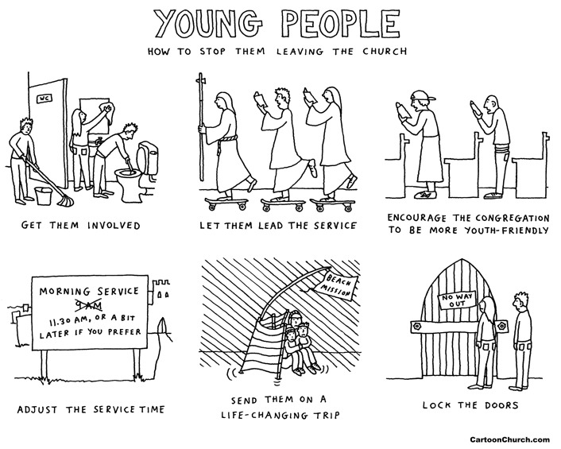
All Age Service
9th May 2021
Becoming a younger church...

All the words you need for this service are on this sheet. Please join in the bits in bold.

Opening Words
From the rising of the sun
till its setting in the west
God's holy Name be praised!

On the lips of children
by babies at the breast
God's holy Name be praised!

In the visions of the old
and the dreaming of the young
God's holy Name be praised!

In the banquet hall of heaven
and the forgotten corners of our hearts
God's holy Name be praised!

Let all that has life and breath
praise the Lord
Amen. We praise the Lord!

Buzz… How old were you when you started coming to church? If you’re on Zoom please put your responses in the chat!

Starter for 10 – some ideas to get us thinking…

Baptism of Matthew Hesman

You are invited to come and stand around the baptism pool at the back – please keep a safe distance from others!

Bible Reading – Mark 10:13-16
At the end we say:

This is the word of the Lord
Thanks be to God

Talk – Nick Shepherd

Letters from a Young Church
Last week the Youth Group wrote a letter to the Archbishop of York, giving their suggestions as to how the Church of England might become a younger church.

Prayer Activity
On your hand write your prayer for the future of the church – it could be the future of the church in this parish, or the Church of England more broadly, or the Anglican church around the world.

If you’re on Zoom, please write your prayers in the chat, and we will put them onto hands.

Lord’s Prayer
Our Father in heaven
hallowed be Your name
Your kingdom come
Your will be done
on earth as in heaven
Give us today our daily bread
Forgive us our sins
as we forgive those
who sin against us
Lead us not into temptation
but deliver us from evil
For the kingdom, the power
and the glory are Yours
now and for ever.
Amen

Blessing
May the love of the Father fill our hearts;
May the love of his son Jesus fill our homes;
And may the grace of the Holy Spirit
bind us together in love
in our families and communities.
And may the blessing of God be with you,
Father, Son and Holy Spirit.
Amen.

Elements of service are taken from Common Worship: Services and Prayers for the Church of England. Copyright acknowledgement: Some material included in this service is copyright: © The Archbishops' Council 2000.

Songs are reproduced under CCLI No. 926815

