Good Shepherd with St. Peter’s

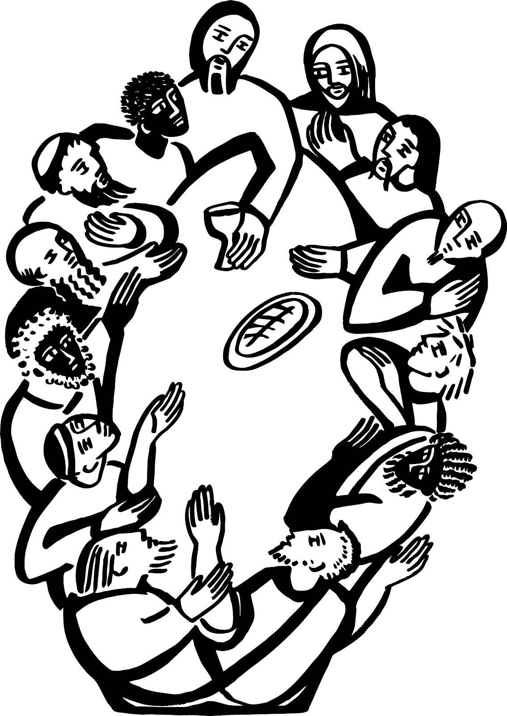

A Service of Holy Communion
for use in ‘Ordinary Time’

All the words you need for this service are in this booklet. Please join in the parts in bold. The service leader will invite you to stand and sit.

Welcome
The service begins with a welcome from the service leader

The Greeting
Grace, mercy and peace
from God our Father
and the Lord Jesus Christ
be with you
and also with you.

An opening hymn is sung here

Prayer of Preparation
Almighty God,
to whom all hearts are open,
all desires known,
and from whom no secrets are hidden:
cleanse the thoughts of our hearts by the inspiration
of your Holy Spirit,
that we may perfectly love you,
and worthily magnify your holy name;
through Christ our Lord.
Amen.

Confession
Our Lord Jesus Christ said:
The first commandment is this:
'Hear, O Israel, the Lord our God is the only Lord.
You shall love the Lord your God with all your heart,
with all your soul, with all your mind, and with all your strength.'

The second is this: 'Love your neighbour as yourself.' There is no other commandment greater than these. On these two commandments hang all the law and the prophets.
Amen. Lord, have mercy.

God so loved the world that he gave his only Son Jesus Christ
to save us from our sins, to be our advocate in heaven, and to bring us to eternal life.

Let us confess our sins in penitence and faith, firmly resolved to keep God's commandments and to live in love and peace with all.

Most merciful God,
Father of our Lord Jesus Christ, we confess that we have sinned in thought, word and deed.
We have not loved you with our whole heart.
We have not loved our neighbours as ourselves.
In your mercy forgive what we have been, help us to amend what we are,
and direct what we shall be; that we may do justly, love mercy, and walk humbly with you, our God.
Amen.

Almighty God,
who forgives all who truly repent,
have mercy upon you,
pardon and deliver you from all your sins, confirm and strengthen you in all goodness,
and keep you in life eternal;
through Jesus Christ our Lord.
Amen.

Gloria in Excelsis

The words of the Gloria may be said or sung. An alternative version of the Gloria may be used on occasion.

Glory to God in the highest,
and peace to his people on earth.
Lord God, heavenly King,
almighty God and Father,
we worship you,
we give you thanks,
we praise you for your glory.
Lord Jesus Christ,

only Son of the Father,
Lord God, Lamb of God,
you take away
the sin of the world:
have mercy on us;
you are seated at the right hand of the Father:
receive our prayer.
For you alone are the Holy One, you alone are the Lord,
you alone are the Most High, Jesus Christ,
with the Holy Spirit,
in the glory of God the Father. Amen.

The Collect (prayer for the day) is usually said here.

The children may leave the service at this point to go to their own activities. The service leader will tell people where to go.

Bible Readings
At the end the reader will say:

This is the word of the Lord.
Thanks be to God.

A hymn is usually sung here

Gospel Reading
When the Gospel reading is announced the reader will say:
Hear the Gospel of our Lord Jesus Christ according to N.
Glory to you, O Lord.

At the end the reader will say:

This is the Gospel of the Lord.
Praise to you O Christ.

Sermon
After the sermon there may be opportunity for quiet reflection.

Creed
We believe in one God,
the Father, the Almighty,
maker of heaven and earth,
of all that is, seen and unseen.
We believe in one Lord,
Jesus Christ,
the only Son of God, eternally begotten of the Father, God from God,
Light from Light,
true God from true God,
begotten, not made,
of one Being with the Father;
through him all things were made.
For us and for our salvation he came down from heaven,
was incarnate from the Holy Spirit and the Virgin Mary
and was made man.
For our sake he was crucified under Pontius Pilate;
he suffered death and was buried.
On the third day he rose again in accordance with the Scriptures;
he ascended into heaven
and is seated at the right hand of the Father.
He will come again in glory to judge the living and the dead, and his kingdom will have no end.
We believe in the Holy Spirit, the Lord, the giver of life, who proceeds from the Father and the Son, who with the Father and the Son is worshipped and glorified,
who has spoken through the prophets.
We believe in one holy catholic and apostolic Church.
We acknowledge one baptism for the forgiveness of sins.
We look for the resurrection of the dead,
and the life of the world to come.
Amen.

Prayers of Intercession
At the end of the prayers, please join in with these words:

Merciful Father,
accept these prayers
for the sake of your Son,
our Saviour Jesus Christ.
Amen.

The Peace
'Where two or three are gathered together in my name,'
says the Lord, 'there am I in the midst of them.'

The peace of the Lord
be always with you
and also with you.

We greet one another, and offer one another a sign of peace.

A hymn is usually sung here. During this hymn an offering may be taken for those who wish to give to the work of the church.

The Eucharistic Prayer

The Lord is here.
His Spirit is with us.

Lift up your hearts.
We lift them to the Lord.

Let us give thanks to the Lord our God.
It is right to give thanks and praise.

Please sit
Father, we give you thanks and praise through your beloved Son Jesus Christ, your living Word,
through whom you have created all things;
who was sent by you in your great goodness to be our Saviour.

By the power of the Holy Spirit he took flesh; as your Son,
born of the blessed Virgin,
he lived on earth and went about among us;
he opened wide his arms for us on the cross; he put an end to death by dying for us; and revealed the resurrection by rising to new life; so he fulfilled your will and won for you a holy people.

On occasion some additional words may be inserted here

Therefore with angels and archangels, and with all the company of heaven,
we proclaim your great and glorious name, for ever praising you and saying:

Holy, holy, holy Lord,
God of power and might,
heaven and earth are full of your glory. Hosanna in the highest.
Blessed is he who comes in the name of the Lord.
Hosanna in the highest.

Lord, you are holy indeed, the source of all holiness;
grant that by the power of your Holy Spirit, and according to your holy will, these gifts of bread and wine may be to us the body and blood of our Lord Jesus Christ;

who, in the same night that he was betrayed, took bread and gave you thanks; he broke it and gave it to his disciples, saying:
Take, eat; this is my body which is given for you; do this in remembrance of me.

In the same way, after supper
he took the cup and gave you thanks; he gave it to them, saying:
Drink this, all of you; this is my blood of the new covenant,
which is shed for you and for many for the forgiveness of sins.
Do this, as often as you drink it,
in remembrance of me.

Great is the mystery of faith:
Christ has died:
Christ is risen:
Christ will come again.

And so, Father, calling to mind his death on the cross,

his perfect sacrifice made once for the sins of the whole world;
rejoicing in his mighty resurrection and glorious ascension, and looking for his coming in glory,
we celebrate this memorial of our redemption.
As we offer you this our sacrifice of praise and thanksgiving,
we bring before you this bread and this cup and we thank you for counting us worthy to stand in your presence and serve you.

Send the Holy Spirit on your people and gather into one in your kingdom all who share this one bread and one cup,
so that we, in the company of all the saints, may praise and glorify you for ever,
through Jesus Christ our Lord;

by whom, and with whom, and in whom, in the unity of the Holy Spirit, all honour and glory be yours, almighty Father,
for ever and ever.
Amen.

Lord’s Prayer
As our Saviour taught us,
so we pray:

Our Father in heaven,
hallowed be Your name,
Your kingdom come,
Your will be done,
on earth as in heaven.
Give us today
our daily bread.
Forgive us our sins
as we forgive those
who sin against us.
Lead us not into temptation,
but deliver us from evil.
For the kingdom, the power,
and the glory are Yours
now and for ever.
Amen

Breaking of the Bread
We break this bread to share
in the body of Christ.
Though we are many, we are one body, because we all share in one bread.

The following response may be sung:

Lamb of God,
you take away the sin of the world, have mercy on us.

Lamb of God,
you take away the sin of the world, have mercy on us.

Lamb of God,
you take away the sin of the world, grant us peace.
Draw near with faith.
Receive the body of our Lord Jesus Christ which he gave for you, and his blood which he shed for you.
Eat and drink in remembrance that he died for you, and feed on him in your hearts
by faith with thanksgiving.

Communion is shared. You will be invited to come forward to the Communion rail to receive. Feel free to kneel or stand. If you would prefer to receive a blessing please keep your hands lowered.

On the first Sunday of the month you will have the opportunity to receive prayer for healing.

Prayer after communion
Father of all,
we give you thanks and praise, that when we were still far off
you met us in your Son and brought us home.
Dying and living,
he declared your love,
gave us grace, and opened the gate of glory.
May we who share Christ's body live his risen life;
we who drink his cup bring life to others;
we whom the Spirit lights give light to the world.
Keep us firm in the hope you have set before us,
so we and all your children shall be free,
and the whole earth live to praise your name;
through Christ our Lord.
Amen.

News and notices are shared
A final hymn will be sung

Blessing
The peace of God,
which passes all understanding,
keep your hearts and minds
in the knowledge and love of God, and of his Son Jesus Christ our Lord;
and the blessing of God almighty,
the Father, the Son, and the Holy Spirit, be among you and remain with you always.
Amen.

Go in peace to love
and serve the Lord.
In the name of Christ. Amen.

You’re warmly invited to stay for tea and coffee after the service

This service is taken from Common Worship: Services and Prayers for the Church of England. Copyright acknowledgement: Some material included in this service is copyright: © The Archbishops' Council 2000. Kyrie Eleison © The Archbishops' Council 2002

